The following figure shows the static configuration of our component-based sample system:

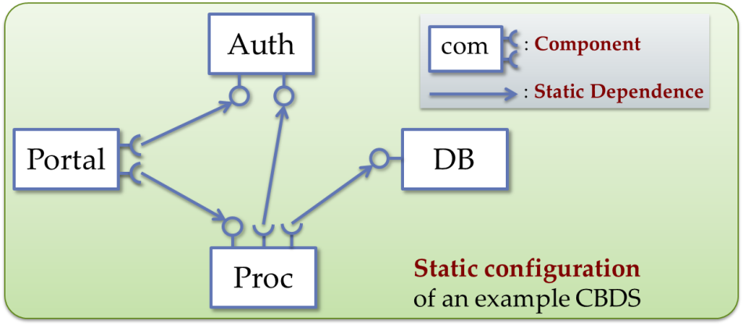

To Run samples in our distribution (tuscany-sca-2.0-DU/samples) in your virtual machine, you need to make sure the following things:

1. Setup your environment path

set PATH=%PATH%:/home/xxxx/tuscany-sca-2.1-DU/bin

1. use NAT network, and make sure your virtual machine's ip address is 10.0.2.15, because our binding uri is this ip.
2. Start all four nodes in your terminals like the following figures.

C:\Users\rgc\AppData\Roaming\Tencent\Users\314017427\QQ\WinTemp\RichOle\SYII{}W}TLL2SV1)F9UIH93.jpgC:\Users\rgc\AppData\Roaming\Tencent\Users\314017427\QQ\WinTemp\RichOle\{5RMYMOF}$)55_5Y`}M0AID.jpgC:\Users\rgc\AppData\Roaming\Tencent\Users\314017427\QQ\WinTemp\RichOle\NAH}ARM2KVIH)$`6~UZ@7JQ.jpgC:\Users\rgc\AppData\Roaming\Tencent\Users\314017427\QQ\WinTemp\RichOle\`GS1%9I{C4UJ@F_`1OM_SRJ.jpg

1. After all nodes are started, we can type “installed” in terminal to see which nodes we have started

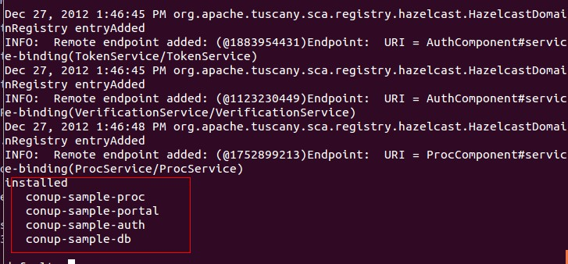

1. Invoke services
2. Invoke PortalComponent’s PortalService in portal node’s terminal using the following command.

invoke PortalComponent/PortalService execute BEGIN nju cs

“execute” is the service method name; “BEGIN, nju, cs” are the three parameters that are required by this method. In our example, we will display all execution path in our result string like the following figure. 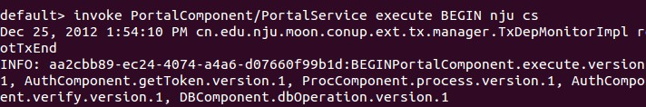

INFO: aa2cbb89-ec24-4074-a4a6-d07660f99b1d:BEGINPortalComponent.execute.version.1, AuthComponent.getToken.version.1, ProcComponent.process.version.1, AuthComponent.verify.version.1, DBComponent.dbOperation.version.1

The Green color string is root transaction id; the blue color string is our input parameter which is used to identify the start of execution; the black color string is our execution path, in the execution path we will also display the implementation’s version

In every component implementation, we have added a variable which was used to identify implementation’s version number. We use this number to test whether our algorithm is right or not.

1. Send Ondemand Setup command to AuthComponent.

If you want to set up these dynamic dependencies, you can use our configuration client to set up.

C:\Users\xiaoxingma\Documents\Tencent Files\1379865045\Image\XW5{Y%]H@N78IW741WGX]ID.jpg

invoke ConfigComponent/ConfService ondemand

For simplicity, here we send ondemand command to AuthComponent. When finish ondemand setup, the following figure will be display in your terminal.

C:\Users\xiaoxingma\Documents\Tencent Files\1379865045\Image\PNA`37)}91QZL`9N5R2_8CV.jpg

1. Send update command to AuthComponent.

Update your component. in paper example, we update AuthComponent, we put our new version of the component implementation in one folder like following figure:

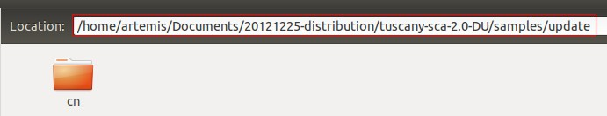

Attention: here the new version of the component implementation is in the form of a .class file with its package name sub-folder.

invoke ConfigComponent/ConfService update /home/artemis/Documents/20121225-distribution/tuscany-sca-2.0-DU/samples/update

For simplicity, here we send update command to AuthComponent. when you finish updating, you can invoke Portal service to test whether your update is right.

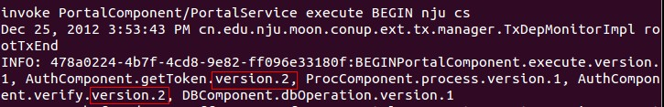

1. We have implement a service access tool to help you make some tests on our algorithm.
2. Start four nodes: portal, proc, auth, db
3. Start config node:

C:\Users\xiaoxingma\Documents\Tencent Files\1379865045\Image\XW5{Y%]H@N78IW741WGX]ID.jpg

1. Start service visitor node:

C:\Users\xiaoxingma\Documents\Tencent Files\1379865045\Image\VLQX41@HA17)DUY3B`2BTDH.jpg

After start this node, you can specify the time of accessing specify service like the following figure: the last parameter is the times that you want to access.

C:\Users\xiaoxingma\AppData\Roaming\Tencent\Users\1379865045\QQ\WinTemp\RichOle\4ZCDKANKZ[_F(A$30]1)HNI.jpg

During the service invoking, you can use config node to send update request to AuthComponent.

If you want to use different algorithm and strategy, you can change them in Conup.xml which locates in bin folder in our distribution.